TO: BOARD OF DIRECTORS
FROM: ROBERT ROESER, Secretary
SUBJECT: MINUTES OF MEETING 17 NOVEMBER 2024
DATE: 11/17/2024
Attachments: (5) Sport Reports – 17 NOVEMBER 2024

B OA R D O F D I R E C T O R S MEETING 8:00 AM VIA ZOOM Video Conference

Member Attendees: Bob Roeser, Jerimiah Niedzwiecki, Mary Kylander, Sheldon Parsons, Donald Patterson, Terry McCarthy, George Cowan, Stephen Jackson, Jesse West, Robert Toran,

Members Excused/Absent: Fran Nowadly, Rickie Kyle, Leigh Henniker, David Moore

The President Mr. Patterson opened the meeting at 8:05 A.M. Motion to approve the agenda as submitted Mr. Niedzwiecki, second Ms. Kylander. Motion Approved.

Mr. Patterson asked if there were additions or corrections to the BOD meeting minutes submitted by Mr. Roeser for the October 20th , 2024, EOA Business meeting. Motion to approve minutes from Mr. Niedzwiecki, second Mr. Toran. Motion approved.

The Treasurer’s Report presented in the standard format of changes since the last scheduled meeting. Mr. Roeser reviewed the outstanding invoices and Income/Expense changes since the last meeting. Motion to approve Treasurer Report by Mr. Niedzwiecki and second Mr. West. Motion approved.

Commissioners Reports

See Attachments for complete report.

Commissioners made the reports with discussion necessary to submissions.

Baseball – Season is finishing next week. Baseball election will be held December 8th @ Mt. Pleasant School in Chesapeake. Secretary will confirm the social/training budget @ $12.00 per sport member.

Football – Championships are this coming weekend. 2025 will be the final season as commissioner.

Softball – As submitted. All invoices have been submitted.

Swimming – Not present.

Volleyball – As submitted.

Old Business:

Website and Evaluation Process – Mr. Patterson has had no contact with Mr. Hilton. Will table conversation until a future meeting.

New Business:
2025 Budget – Budget discussion ensued and was completed. Mr. Niedzwiecki motion to approve the 2025 budget as amended, second Mr. Toran. Motion approved.
Motion to Adjourn, Mr. Cowan and second Mr. Moore @ 9:02 A.M. Motion approved.
Future Board Meetings: - January 12th, February 9th, March 2nd Business Meeting, April 6th

Swimming & Diving Report
EOA Board of Directors’ Meeting
November 17, 2024

- COMMISSIONER ASSIGNMENTS
  - Commissioner worked zero assignments in October and November.

- OUTSTANDING INVOICES.
  - There are no outstanding or overdue invoices at this time.

- CONTRACT STATUS.
  - Swimming and Diving is using the current and approved high school contract.

- SWIMMING & DIVING COMMITTEE.
  - Committee Chairperson: TBA
  - Diving Representative: Doria McConnell
  - Swim and USA Representative: Bonnie Johnson
  - Dry Deck Representative: Will Galbreath

- EOA COMMITTEE REPRESENTATIVES AND OTHER DUTIES.
  - Swimming & Diving Representative: David Moore

- OTHER ITEMS.
  - Officials Training for 2024-2025 season are Nov 17, 20, & 21.
  - Swimming & Diving competition starts in December.
  - Working with VHSL to start preparing 2025 state championship meets.

Leigh Henniker
Swimming & Diving Commissioner
November 15, 2024

^{VOLLEYBALL REPORT}
EOA BOARD OF DIRECTOR’S MEETING
^{17 NOVEMBER 2024}
1. COMMISSIONER ASSIGNMENTS. I have worked no EOA assignments since the last Board of Directors’ meeting.

2. OUTSTANDING INVOICES.
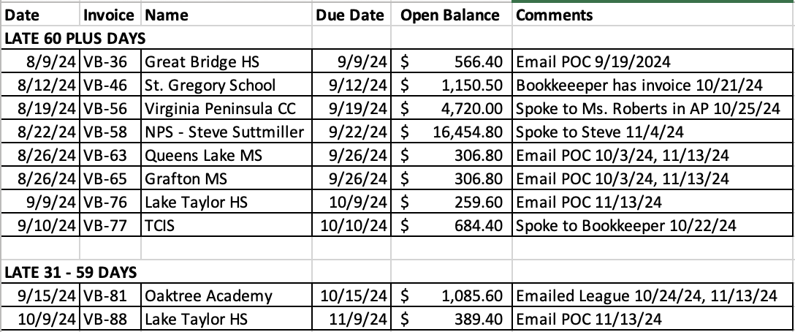

3. CONTRACT STATUS.
a. All contracts are fully executed.

4. (SPORT) COMMITTEE.
a. Composition of Volleyball Committee effective January 2022 is:
Barb Besal, Chair George Cowan, Delegate Susie Fleenor
Scott Hanly Greg Bornako Larry Stolarski
Stella Salyer Brian Randall Gina Bissmeyer
Dick Robbins Doug McDonald Mary Waite

5. EOA COMMITTEE REPRESENTATIVES AND OTHER DUTIES.
Rules Interpreter Robert Kyle
Line Judge Certifications Scott Hanly
Evaluations Chair Lori Colonna
Judicial Committee Tammy Elliott
Nominating and Elections Committee Scott Hanly

6. Playoffs
a. District, Regional and Private school playoffs are completed.
b. 10/16/24, seven VHSL State quarterfinal matches, two schools are from the Peninsula District because they do not like their association.
c. VHSL Class 4 Boys State Final crew: Destiny Coats, Bob Roeser, Fallon Wilson, and Shae Stewart

Mary Kylander
Volleyball Commissioner
November 15, 2024

Baseball Commissioner Report
EOA Board of Directors’ Meeting
November 17, 2024
1. COMMISSIONER ASSIGNMENTS.
I have worked 0 games for EOA since the last BOD meeting.

2. OUTSTANDING INVOICES / PAYMENTS RECEIVED. (ALL Invoices 30+ days)
OUTSTANDING AND OVERDUE INVOICES
Customer | Due Date | Amount | Status as of BOD meeting
All Fall Invoices | TBD | TBD | Being sent out this week and next week

3. CONTRACT STATUS.
Customer | Contact | Date Sent | Status as of BOD meeting
- | - | - | Travel contracts will be up this winter

4. BASEBALL COMMITTEE.
Jesse West (Commissioner) (voting) | Mike Fencil  (TBA) (voting) | Tim Morris  (Uniforms) (voting) | Midget Campbell (TBA) (voting)
Eddie Augins  (Assist Scheduling) (voting) | Chris Stevens (Recruiting) (voting) | Mike Loyd  (Evaluation)(voting) | Ron Rigby (Chair) Mentors (voting)
Joe Pallazzo (Rules) (non-voting) | Ben Keller (Delegate) (voting)

5. EOA COMMITTEE REPRESENTATIVES AND OTHER DUTIES.
Off-Field Evaluator | Off-Field Evaluator | Nominating & Elections rep.
Bill McInnis | Jim Smith | Peter Daley

6. Recruiting/New Umpires: We have 45 new umpires who have joined EOA in 2024. The next new umpire class will be at the end of January. Already getting requests to join now.
7. September Commissioner Election. This election has been postponed to December 8th at 2p.
8. Scheduling.: All scheduling for 2025 is on hold pending the result of the election
9. Veteran Umpire TRAINING. We held two clinics this fall that were both well-attended. I have plans to hold winter trainings as we did the last two years depending on election. Need to clarify training budget.
10. STATISTICS. As of the report date. Current totals for 2024 season.
Total games scheduled as of report date | Total games cancelled as of report date | Total game fees as of report date
6427  (2023 = 7058total) | 1386  (2023 = 1402) | $690,320  (2023 =$694,075.00)

Jesse West
Baseball Commissioner
November 17, 2024

Report of The Softball Commissioner
EOA Board of Directors
November 17, 2024

- Commissioner Assignments.
I have worked the below assignments for the association.
Game # | Date | League | Amount
17156 | 11/10/2024 | VBLL | 58.00
17157 | 11/10/2024 | VBLL | 58.00

- Outstanding Invoices

Customer | Invoice | Amount | Status
Norfolk Public Schools – Steve Suttmiller | SB-1036 | 886.00 | Submitted 10/23/2024
Chesapeake Public Schools | SB-1037 | 145.50 | 10/29/2024
VBLL | SB-1039 | 485.96 | 11/11/2024

- Contract Status:
  - New 2-year contract signed with Bryant & Stratton
- Softball Committee: Cara Headrick- Chair, Sheldon Parson - Delegate, Robert Toran, Scott Warren, Sam Serman, Rickie Kyle, Laura Kaiser, and Vern Aunchman
- Committees.
Judicial- Donald Richardson
Election- Robert Toran
- Fall Ball is complete. Norfolk MS championship was on 10/17. Chesapeake MS championship was on 10/28.
  - 6 officials worked in the Norfolk Middle Schools semifinals and finals.
  - 8 officials worked in the Chesapeake Middle Schools semifinals and finals.
- Softball Committee almost complete with next year’s training schedule. Next meeting of the committee is Nov 25 at Salem HS.

Eastern Officials Association
November 2024, Football Report
1. Commissioner Assignments. I have worked 5 games during this reporting period.
2. Outstanding Invoices.
Virginia Beach Football League Invoice #742 $2,265.60
3. Contract Status.
All Contracts are current.
4. Football Committee:
Rickie Kyle – Delegate
Scott Warren
Rocket Jackson
Donnie Pennington SR
EOA Committee Representatives and Other Duties:
Rules Interpreter: Mike Barba
Judicial Committee: Timerek Johnson
Nominating and Elections: Roscoe Hatten
5. Football season will end on November 23 with 3 Championship games at Kellam High School.
6. As of right now, next year will be my last year as Commissioner.

Terry McCarthy, Football Commissioner
November 13, 2024

