TO: BOARD OF DIRECTORS
FROM: ROBERT ROESER, Secretary
SUBJECT: MINUTES OF MEETING 20 OCTOBER 2024
DATE: 10/20/2024
Attachments: (5) Sport Reports – 20 OCTOBER 2024

B OA R D O F D I R E C T O R S MEETING 8:00 AM VIA ZOOM Video Conference

Member Attendees: Bob Roeser, Jerimiah Niedzwiecki, Mary Kylander, Sheldon Parsons, Donald Patterson, Terry McCarthy, George Cowan, Stephen Jackson, Jesse West, Dave Moore, Leigh Henniker

Members Excused/Absent: Robert Toran, Fran Nowadly, Ben Keller

The President Mr. Patterson opened the meeting at 8:07 A.M. Motion to approve the agenda as submitted Mr. Cowan, second Mr. Moore. Motion Approved.

Mr. Patterson asked if there were additions or corrections to the BOD meeting minutes submitted by Mr. Roeser for the August 11th , 2024, EOA Business meeting. Motion to approve minutes from Mr. Kyle, second Mr. Moore. Motion approved.

The Treasurer’s Report presented in the standard format of changes since the last scheduled meeting. Mr. Roeser reviewed the outstanding invoices and Income/Expense changes since the last meeting. Motion to approve Treasurer Report by Mr. Niedzwiecki and second Mr. Kyle. Motion approved.

Commissioners Reports

See Attachments for complete report.

Commissioners made the reports with discussion necessary to submissions.

Baseball – Baseball election will be held December 8th @ Mt. Pleasant School in Chesapeake.

Football – As written, board acknowledged Terry’s 50 years as IAABO Basketball member.

Softball – As written, collaborating with customers to renew contracts.

Swimming – Working with VHSL to schedule meets. Training will begin November 17th.

Volleyball – As written.

Old Business:

Scholastic Contracts – We received all new contracts from the five municipalities.

Website and Evaluation Process – Spoke to Mr. Hilton about our private link to deposit minutes and contracts. Was asked by Mr. Patterson to withhold payment to Hilton Multimedia until some of our issues have been resolved.

New Business: No new business
Motion to Adjourn, Mr. Cowan and second Mr. Moore @ 8:34 A.M. Motion approved.
Future Board Meetings: - November 17th, January 12th, February 9th, March 2nd Business Meeting, April 6th

Swimming & Diving Report
EOA Board of Directors’ Meeting
October 20, 2024

- COMMISSIONER ASSIGNMENTS
  - Commissioner worked zero assignments in August and September.

- OUTSTANDING INVOICES.
  - There are no outstanding or overdue invoices currently.

- CONTRACT STATUS.
  - Swimming and Diving is using the current and approved high school contract.

- SWIMMING & DIVING COMMITTEE.
  - Committee Chairperson: TBA
  - Diving Representative: Doria McConnell
  - Swim and USA Representative: Bonnie Johnson
  - Dry Deck Representative: Will Galbreath.

- EOA COMMITTEE REPRESENTATIVES AND OTHER DUTIES.
  - Swimming & Diving Representative: David Moore

- OTHER ITEMS.
  - Officials Training for 2024-2025 season are Nov 17 & 20.
  - Swimming & Diving competition starts in December.
  - Working with VHSL to start preparing 2025 state championship meets.

Leigh Henniker
Swimming & Diving Commissioner
October 18, 2024

Baseball Commissioner Report
EOA Board of Directors’ Meeting
October 20, 2024
1. COMMISSIONER ASSIGNMENTS.
I have worked 0 games for EOA since the last BOD meeting.

2. OUTSTANDING INVOICES / PAYMENTS RECEIVED. (ALL Invoices 30+ days)
OUTSTANDING AND OVERDUE INVOICES
Customer | Due Date | Amount | Status as of BOD meeting
- | - | - | -
- | - | - | -
- | - | - | -

3. CONTRACT STATUS.
Customer | Contact | Date Sent | Status as of BOD meeting
KPB Travel | Tim Costa | September | Signed and confirmed

4. BASEBALL COMMITTEE.
Jesse West (Commissioner) (voting) | Mike Fencil  (TBA) (voting) | Tim Morris  (Uniforms) (voting) | Midget Campbell (TBA) (voting)
Eddie Auggins  (Assist Scheduling) (voting) | Chris Stevens (Recruiting) (voting) | Mike Loyd  (Evaluation)(voting) | Ron Rigby (Chair) Mentors (voting)
Joe Pallazzo (Rules) (non-voting) | Ben Keller (Delegate) (voting)

5. EOA COMMITTEE REPRESENTATIVES AND OTHER DUTIES.
Off-Field Evaluator | Off-Field Evaluator | Nominating & Elections rep.
Bill McInnis | Jim Smith | Peter Daley

6. Recruiting/New Umpires: We had 20 people complete the new umpire training this fall.
7. September Commissioner Election. Need to discuss.
8. RECREATION.: Recreation games end November 9th
9. Veteran Umpire TRAINING. We completed a highly successful 3-umpire training at Norfolk State two weeks ago. Jeff Doy was in attendance to help. We have a 2-umpire clinic coming up the first week of November.
10. STATISTICS. As of the report date. Current totals for 2024 season.
Total games scheduled as of report date | Total games cancelled as of report date | Total game fees as of report date
6315  (2023 = 7058total) | 1340  (2023 = 1402) | $678,205.00  (2023 =$694,075.00)

Jesse West
Baseball Commissioner
October 18, 2024

Volleyball Report
EOA Board of Director’s Meeting
October 20th, 2024

1. COMMISSIONER ASSIGNMENTS. I have worked no EOA assignments since the last Board of Directors’ meeting.

2. OUTSTANDING INVOICES.
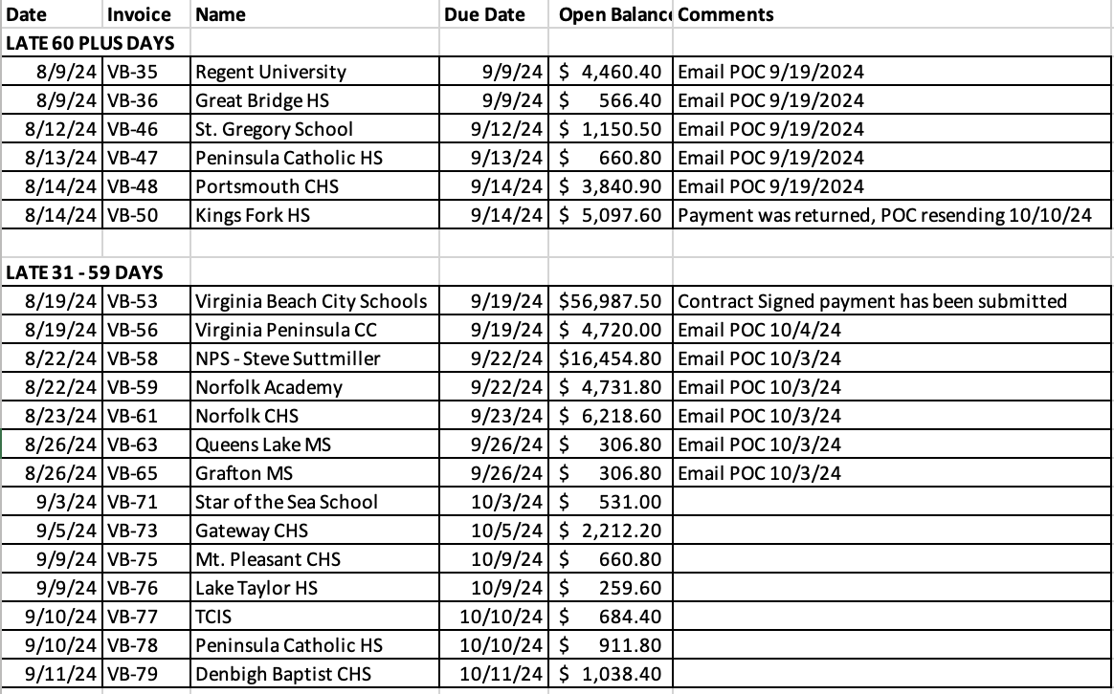

3. CONTRACT STATUS.
a. Military – Coastal Clash Volleyball Tournament - completed.

4. (SPORT) COMMITTEE.
a. Composition of Volleyball Committee effective January 2022 is:
Barb Besal, Chair George Cowan, Delegate Susie Fleenor
Scott Hanly Greg Bornako Larry Stolarski
Stella Salyer Brian Randall Gina Bissmeyer
Dick Robbins Doug McDonald Mary Waite

5. EOA COMMITTEE REPRESENTATIVES AND OTHER DUTIES.
Rules Interpreter Robert Kyle
Line Judge Certifications Scott Hanly
Evaluations Chair Lori Colonna
Judicial Committee Tammy Elliott
Nominating and Elections Committee Scott Hanly

6. Playoffs
a. Some MS playoffs start next week.
b. Private school playoffs start this weekend.
c. VHSL playoffs start 11/2 (Regional Tournament)

Mary Kylander
Volleyball Commissioner
October 17, 2024

Eastern Officials Association
October 2024, Football Report
1. Commissioner Assignments. I have worked six games during this reporting period.
2. Outstanding Invoices.
Great Neck Tackle Invoice #140 $2,186.60
Great Neck Flag Invoice #141 $7457.60
3. Contract Status.
All Contracts are current.
4. Football Committee:
Rickie Kyle – Delegate
Scott Warren
Rocket Jackson
Donnie Pennington SR
EOA Committee Representatives and Other Duties:
Rules Interpreter: Mike Barba
Judicial Committee: Timerek Johnson
Nominating and Elections: Roscoe Hatten
5. On Tuesday I received the International Association of Approved Basketball Officials award for 50 years of basketball officiating.

Terry McCarthy, Football Commissioner
October 16, 2024

Report of The Softball Commissioner
EOA Board of Directors
October 20, 2024

- Commissioner Assignments.
I have not worked any assignments since the last BOD meeting.

- Outstanding Invoices

Customer | Invoice | Amount | Status
Norfolk Public Schools – Steve Suttmiller | SB-1033 | 3610.80 | Spoke with Steve Suttmiller on 10/15. Payment has been submitted
Norfolk Public Schools – Booker T Washington | SB-1012 | 601.80
Norfolk Public Schools - Lake Taylor HS | SB-1026 | 188.80

- Contract Status:
  - New Contract established with VBLL
  - Working with Bryant & Stratton on new contract
- Softball Committee: Cara Headrick- Chair, Sheldon Parson - Delegate, Robert Toran, Scott Warren, Sam Serman, Rickie Kyle, Laura Kaiser, and Vern Aunchman
- Committees.
Judicial- Donald Richardson
Election- Robert Toran
- Fall Ball is coming to completion. Norfolk championship on 10/17. Chesapeake championship on 10/28.
  - 6 officials worked in the Norfolk Middle Schools semifinals and finals.
  - 8 officials to work in the Chesapeake Middle Schools semifinals and finals.
- Softball Committee beginning to plan for next year’s training.

